**SSCBS**

**MAYANK CHOPRA**

**ROLLNO -23719**

**Burp suite**

**It is a proxy tool for analysing requests and analysing responses, it is the most widely used software for web application penetration testing, it has several features by which we can perform scanning, manual scanning. this tool comes as community edition (for student, leaners) and paid professional version (for industry experts)**

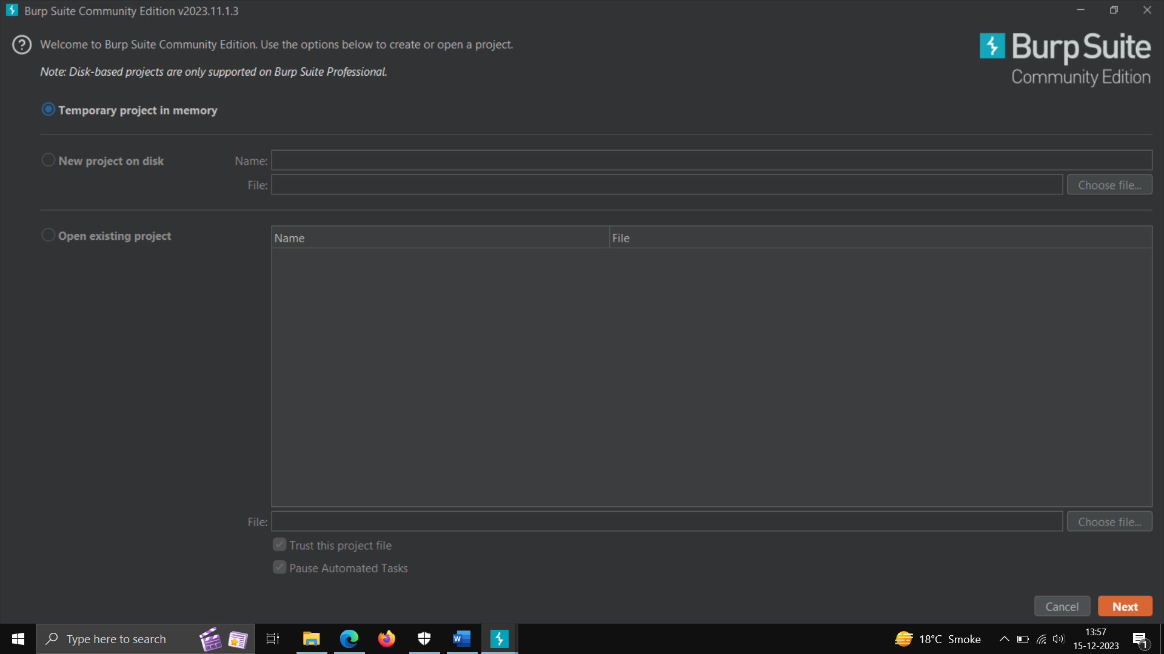

**ZAP PROXY**

**It is a open source tool used for scanning and manually scanning for web application, it is usually used for vulnerability assessment by the industry (VA).**

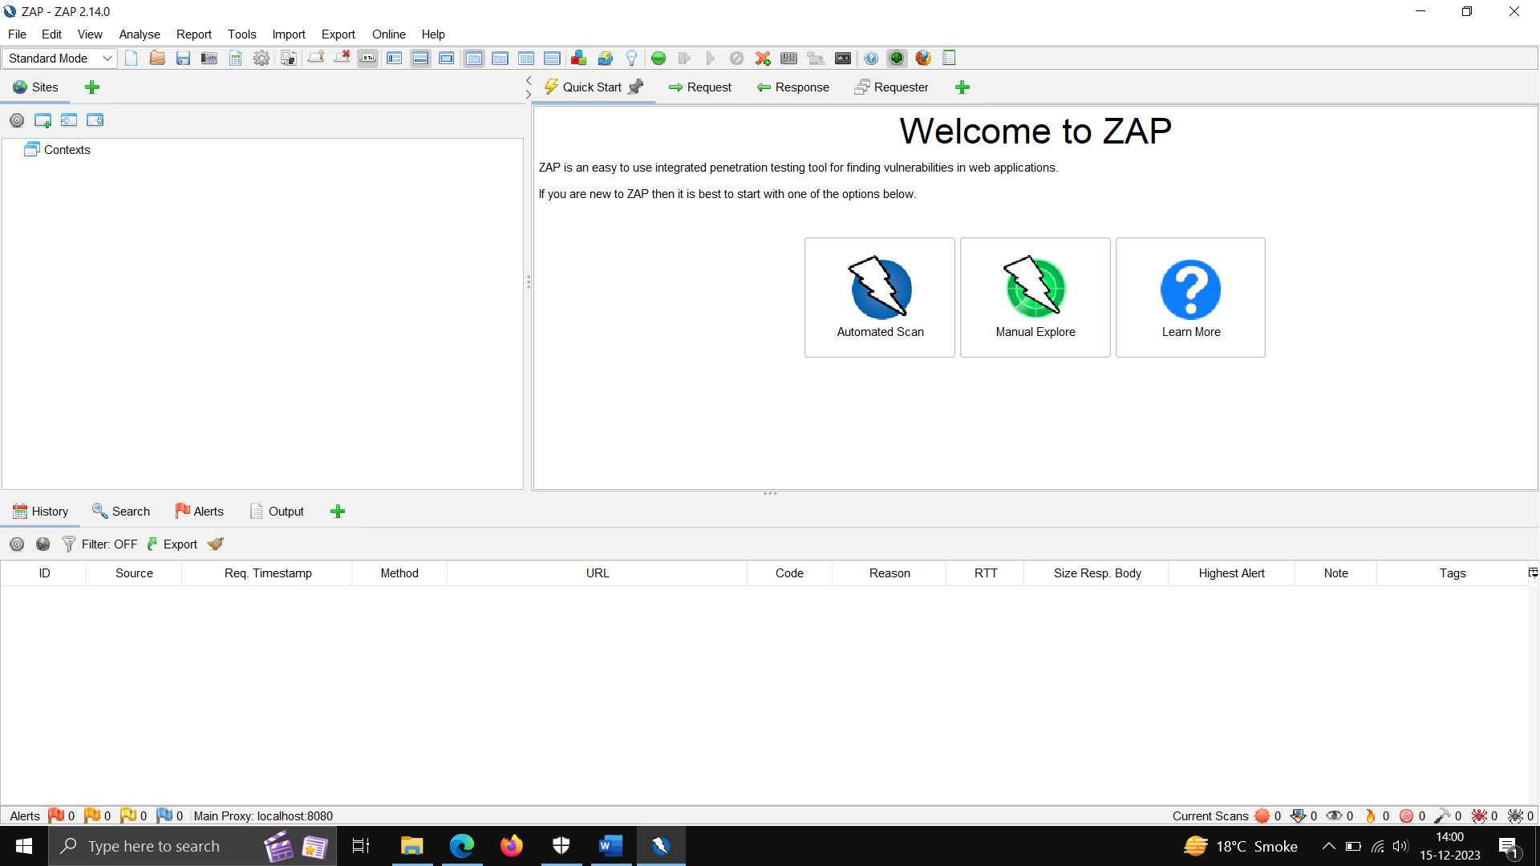

**PORTSWIGGER LAB**

**It is world first lab which has explained attacks deeply, use for finding more bugs. It is used for website penetration testing practice, mobile application concepts, etc.**

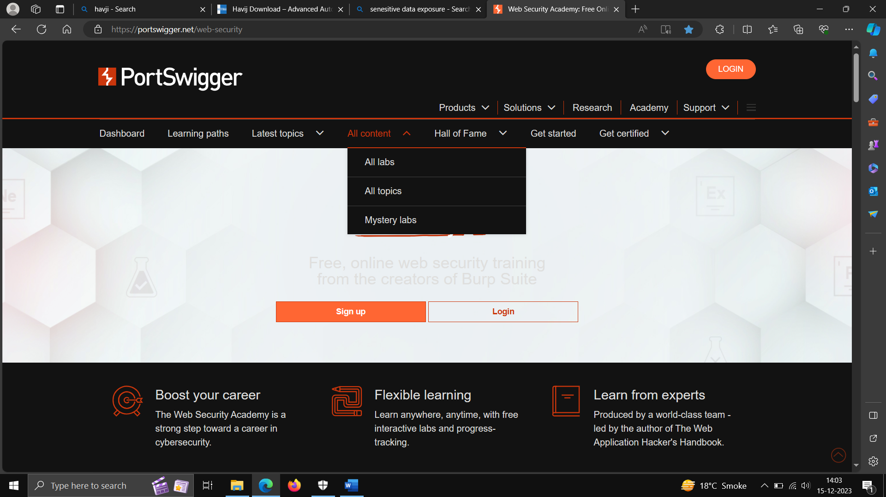

**NMAP – it is a port scanning tools and supports both Linux and windows.**

